Task 1: session (01AIML) Assignment Question

- Name of student :sakshi ganesh tipale
- Domain: Artificial intelligence and machine learning .
- Collage & Branch : zeal polytechnic,pune(AIML) .

Q1 : Variables & Naming Rules)
Create variables to store the following information about yourself:
ANS:

full_name = "Sakshi Tipale" # String
age = 20 # Integer
height_meters = 1.60 # Float
is_student = True # Boolean

print("Full Name:", full_name)
print("Age:", age)

print("Height:", height_meters)
print("Student:", is_student)

print("\nData Types:")
print(type(full_name))

print(type(age))
print(type(height_meters))
print(type(is_student))

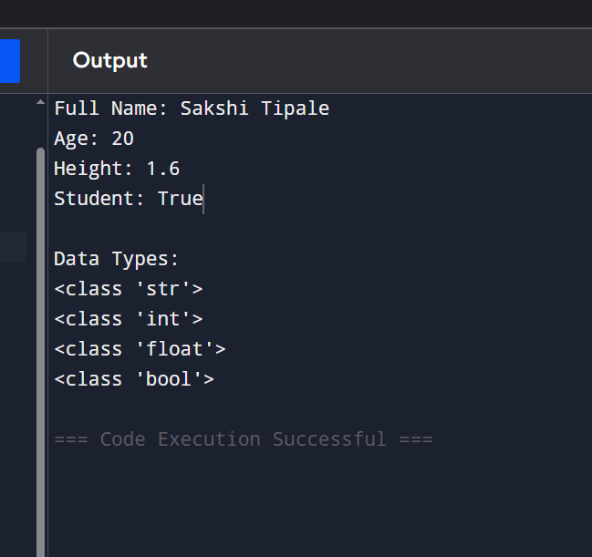

Q2: Data Types)
Write a Python program that:
a) Creates one variable of each core data type: str, int, float, and bool.
b) Prints each variable along with its data type using type().
c) Try converting the integer to float and float to integer. Print the results and explain the output.
ANS:
number = 100
price = 99.99
available = True
print("String Value:", name)
print("Type:", type(name))

print("Integer Value:", number)
print("Type:", type(number))

print("Float Value:", price)
print("Type:", type(price))

print("Boolean Value:", available)
print("Type:", type(available))

# Type Conversion
float_number = float(number)
int_price = int(price)
print("\nAfter Conversion:")

print("Integer to Float:", float_number)
print("Type:", type(float_number))

print("Float to Integer:", int_price)
print("Type:", type(int_price))

# Explanation:
# float(number) converts integer 100 into 100.
# it(price) removes the decimal part from 99.99 and becomes 99
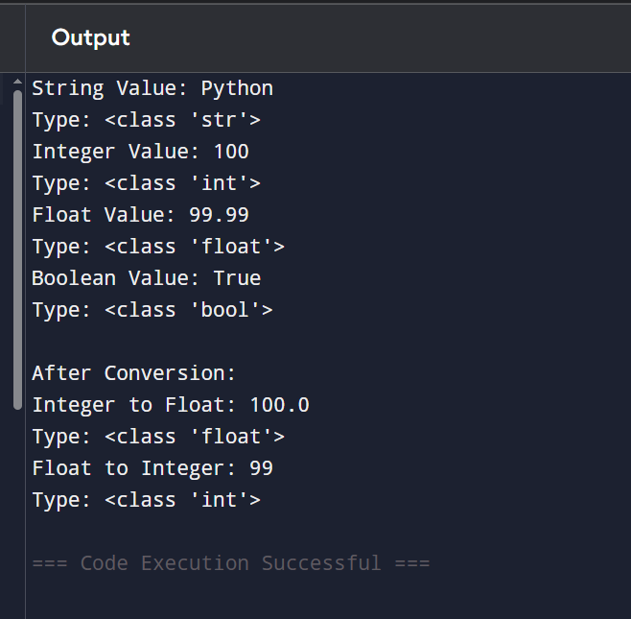

Q3: Operators - Arithmetic)

Write a program that takes two numbers a = 15 and b = 4 and prints the results of:

Addition, Subtraction, Multiplication, Division, Floor Division, Modulo, and Exponentiation.

Add comments explaining the difference between / and // operators with an example.
ANS: # Assigning values
a = 15
b = 4
# Arithmetic Operations
print("Addition:", a + b)
print("Subtraction:", a - b)
print("Multiplication:", a * b)
print("Division:", a / b)
print("Floor Division:", a // b)
print("Modulo:", a % b)
print("Exponentiation:", a ** b)
# Difference between / and //
# / returns the exact decimal result
# // returns only the integer quotient
print("\nExample:")
print("15 / 4 =", 15 / 4)
print("15 // 4 =", 15 // 4)

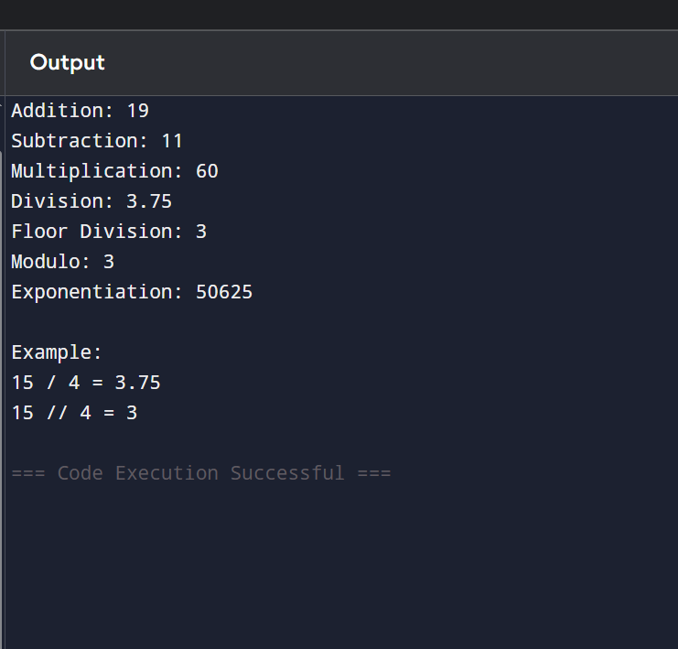

Q4: Operators - Comparison & Logical)
Given:
X 25
y = 30Session 01 (AIML)-Assignment Questionsz = 25
Write expressions using comparison and logical operators to check:
1. Is x greater than y?
2. Is x equal to z?
3. Is x less than or equal to y AND y is not equal to z?
4. Is x greater than y OR x equal to z?
Print all results with descriptive messages.
ANS: # Assigning values
x = 25
y = 30
z = 25
# Comparison and Logical Operations
print("1. Is x greater than y?")
print(x > y)
print("\n2. Is x equal to z?")
print(x == z)
print("\n3. Is x less than or equal to y AND y is not equal to z?")
print((x <= y) and (y != z))
print("\n4. Is x greater than y OR x equal to z?")
print((x > y) or (x == z))

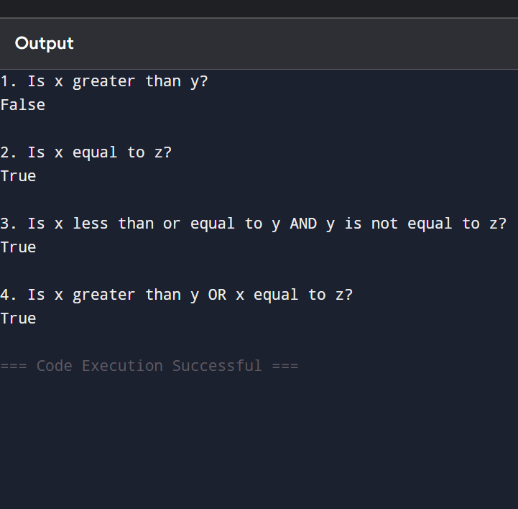

Q5: Input/Output)
Write a program that asks the user to input:
Their name
Their birth year
Then calculate and print their current age (assume current year is 2026). Use proper formatting and add comments explaining why you need to convert the input.
ANS:
# Ask user for name
name = input("Enter your name: ")
# Ask user for birth year
birth_year = int(input("Enter your birth year: "))
# Current year
current_year = 2026
# Calculate age
age = current_year - birth_year
# Display result
print("\nHello,", name)
print("Your age is:", age)
# We convert birth_year to int because input() always returns a string.
# Mathematical operations cannot be performed directly on strings.

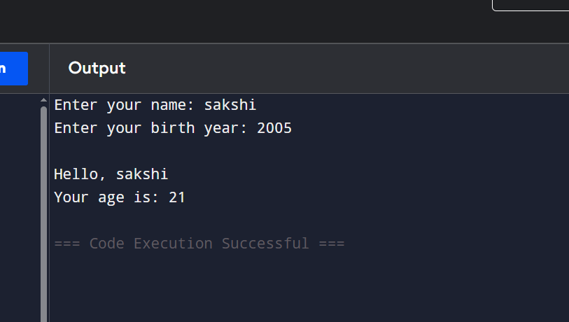
Q6: Combined - Variables, Operators & Input)
Create a simple BMI Calculator:
Take height (in meters) and weight (in kg) as input from the user.
Calculate BMI using the formula: BMI = weight / (height ** 2)
Print the BMI rounded to 2 decimal places.
Include appropriate comments.
ANS: # BMI Calculator
# Take height input in meters
height = float(input("Enter your height (in meters): "))
# Take weight input in kilograms
weight = float(input("Enter your weight (in kg): "))
# Calculate BMI
bmi = weight / (height ** 2)
# Display BMI rounded to 2 decimal places
print("Your BMI is:", round(bmi, 2))
# Formula:
# BMI = weight / (height * height)
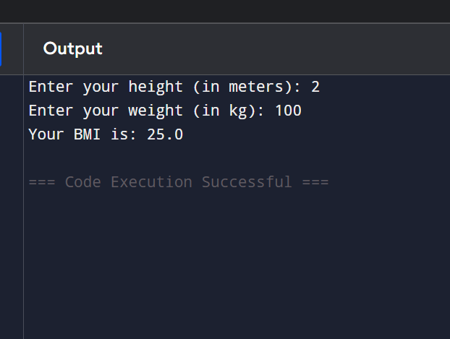
Q7: Comments)
Write a small program that calculates the area and perimeter of a rectangle.
Take length and width as input
Use at least 5 meaningful comments (single-line and one multi-line comment).
Follow good commenting practices (explain why, not what for obvious lines).
ANS:
Rectangle Calculator
This program calculates the area and perimeter
of a rectangle using user-provided dimensions.
# Taking length input from the user
length = float(input("Enter the length: "))
# Taking width input from the user
width = float(input("Enter the width: "))
# Area helps determine the amount of surface covered
area = length * width
# Perimeter helps determine the total boundary length
perimeter = 2 * (length + width)
# Displaying the calculated values clearly
print("\nArea of Rectangle =", area)
# Showing perimeter separately for better readability
print("Perimeter of Rectangle =", perimeter)

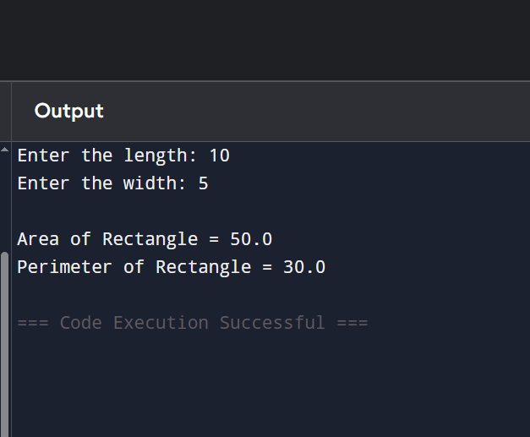
Q8: Operators - Assignment & Membership)
["mango", "apple", "banana", "cherry"] fruits
score 50
Perform the following operations:
1. Add 25 to score using assignment operator (+=).
2. Check if "apple" is in the fruits list.
3. Check if "grape" is not in the list. Print all results with clear messages.
ANS: # Creating a list of fruits
fruits = ["mango", "apple", "banana", "cherry"]
# Initial score
score = 50
# Add 25 to score using assignment operator
score += 25
# Check membership
apple_present = "apple" in fruits
grape_absent = "grape" not in fruits
# Print results
print("Updated Score:", score)
print("Is 'apple' in the fruits list?", apple_present)
print("Is 'grape' not in the fruits list?", grape_absent)
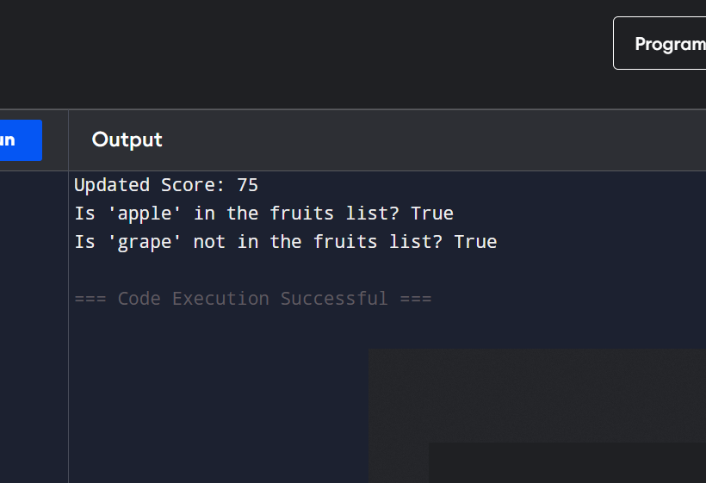
Q9: Mini Project All Concepts)
Write a Student Profile Generator program that:
Takes input: name, age, city, and marks in 3 subjects.
Calculates total marks and percentage.
Prints a formatted profile with all information.
Use meaningful variable names, proper comments, and different data types.
ANS: # Student Profile Generator
# Taking student details
name = input("Enter your name: ")
age = int(input("Enter your age: "))
city = input("Enter your city: ")
# Taking marks of 3 subjects
subject1 = float(input("Enter marks in Subject 1: "))
subject2 = float(input("Enter marks in Subject 2: "))
subject3 = float(input("Enter marks in Subject 3: "))
# Calculating total marks
total_marks = subject1 + subject2 + subject3
# Calculating percentage
percentage = total_marks / 3
# Displaying student profile
print("\n----- STUDENT PROFILE -----")
print("Name:", name)
print("Age:", age)
print("City:", city)
print("Subject 1 Marks:", subject1)
print("Subject 2 Marks:", subject2)
print("Subject 3 Marks:", subject3)
print("Total Marks:", total_marks)
print("Percentage:", round(percentage, 2), "%")
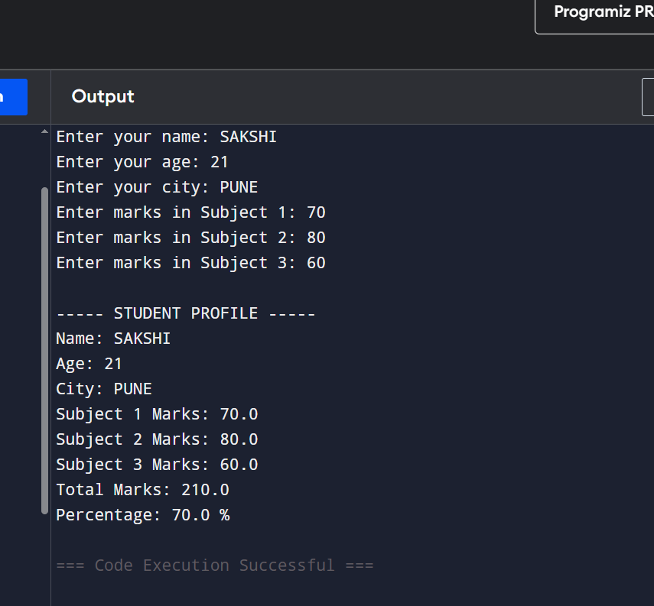

Q10: Debugging & Understanding)
The following code has some issues. Correct it and add proper comments
explaining the fixes:
Name "Alice"
age 20
city
Amsterdam
print("My name is" + Name)
print("I am" age "years old")
print("I live in " city)
#Check if age is greater than 18 and print message
print("Adult:" age > 18)
ANS: # Store personal information in variables
name = "Alice"
age = 20
city = "Amsterdam"
# Print name
print("My name is " + name)
# Convert age to string while concatenating
print("I am " + str(age) + " years old")
# Print city
print("I live in " + city)
# Check if age is greater than 18
print("Adult:", age > 18)
